Help TV’s “the Lion Man”, Craig Busch
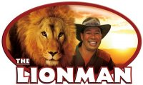
Hi all of you who have watched ”The Lion Man” on TV! It is repeated regularly on Sky, but for those who haven’t seen it, it is about an amazing guy called, Craig Busch. All by himself through years of devotion he has established a park in New Zealand called “Zion Wildlife Gardens”. It is a sanctuary for big cats where Craig and his staff work hands-on building bonds with these gorgeous animals and creating an existence that they otherwise would not have. To date the park houses more than 40 beautiful big cats, safe from hunters. His sanctuary is home to Zion, the magnificant lion who was famously chosen as the face for Aslan in the recent Narnia & Prince Caspian films.

Craig’s Mother Patricia came to the park in 2006 to financially “assist” him following a period of personal difficulty. However now she has overstepped her authority and has side-lined her own son from the business he has set up, and isolated him from his big cats and the marvellous work he has been doing. It is a terrible thing she has done to her son and just as bad, the big cats are really missing their Dad!!

Craig “The Lion Man” himself has said: “I believe my cats miss me as much as I miss them. I do get to see them but not very often and I am not able to go in with them. Some of them have been affected emotionally but the most impact has been on Gandor, Shikira, Zion and Shia. It is not their fault that all this is happening. I need to get back to them as soon as possible”.

Watch this amazing heart rendering video of The Lion Man on You Tube where you can without doubt see and hear how upset his big cats Zion and Gandor are:
http://www.youtube.com/watch?v=i53xudKDb7Y&feature=related

The special bond between The Lion Man and the big cats means they see Craig as their Father, and they need him just as much as he needs them. Right now he has sold almost everything he has just to raise money in his fight to get back the park and cats he misses SO much!

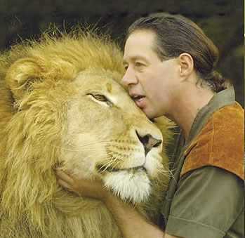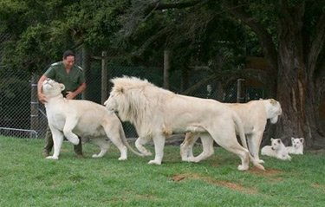

Continued on next page…

Help TV’s “the Lion Man”, Craig Busch
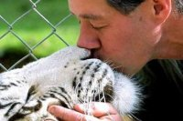
Craig’s Mother and the new management are misleading visitors of the park and the Zion website that The Lion Man is still in charge and are riding on the back of the success and global fame Craig has brought to it. He now needs the support of ALL his fans to show Patricia that we want Craig to come back. Because without the Lion Man, the long term future of Zion Wildlife Gardens and these endangered species is at risk, not to mention The Lion Man TV show which has captured so many hearts across the world and raises the awareness of the near extinction of these beautiful animals. The cats are 50% of the park and The Lion Man is the other 50%, so we need to get him back NOW!! So come on everybody, we cannot accept this. We all have to do something to help instead of just sitting here doing nothing. Even though you might be living in a country far away, you can still help Craig and his big cats!

There are a number of ways you can help:
- Go to The Lion Man’s very own website www.nzlionman.com where you can see a fantastic video of his work & buy merchandise signed by The Lion Man.
- See The Lions Mans own personal plea’s to his fans for help on You Tube: http://www.youtube.com/watch?v=ocNyTtNrjP8&feature=related
and http://www.youtube.com/watch?v=dFcgNOQoFIw&feature=related
- Sign the official petition to bring The Lion Man back to Zion Wildlife Gardens at: http://www.gopetition.co.uk/online/24579.html
- Join his Facebook Fan’s page where he often writes himself. Go to http://www.facebook.com/pages/NZ-Lionman-Craig-Busch/43253796601?ref=ts or once on Facebook, just search for: “NZ Lionman - Craig Busch”. There you can join the fan club in and read a lot more about what is going on right now.
- Go to Craig’s own ebay page on: http://members.ebay.co.uk/ws/eBayISAPI.dll?ViewUserPage&userid=nzlionman where you can also buy merchandise signed by The Lion Man.
- Do all your Internet shopping through http://www.easyfundraising.org.uk/Register/?char=18351, a fabulous site where big high street names will donate to The Lion Man’s cause on your behalf every time you buy from them through this site.
- Change your Internet search engine to http://craigbusch.easysearch.org.uk where you can search through the normal big search engines except money gets donated every time you do it through this site.
- Watch the heart rendering video fans have created on You Tube: http://www.youtube.com/watch?v=iT2NwqH6ajg&feature=related

This REALLY is worthwhile - if you have ever seen just one episode of The Lion Man, you will be hooked! This guy is the Steve Irwin of New Zealand!! We really hope you will participate in whichever way you can, because The Lion Man needs you guys, and the big cats need help more than anything to get back their Dad!!

***** Thank you for your support and here’s to a 4th Lion Man TV Series *****

